Smart Quiz Assessment Output

Input images  
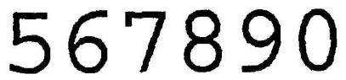



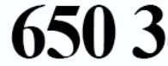

Output

